STUDENT CASE STUDY EXECUTION PROJECT

DEPARTMENT | FED
SUBJECT | DSA-2
ACADEMIC YEAR | 2025-2026
FACULTY NAME | Mrs. Deepika
STUDENT NAME | Gayathri Srivalli Kajuluri
ROLL NO | 2520080010
BRANCH | AI&DS
COURSE OUTCOME
CASE STUDY TOPIC:
Amazon warehouse — point-in-time inventory snapshots for accounting reconciliation. A regional warehouse stocks n = 8 SKU-categories. Inventory updates (add/remove units) happen continuously throughout the day. Once a day, accounting needs to query 'what was the total stock in categories 3..6 as of 11:30 AM yesterday?'
- a range-sum query against a historical version of the array. Naively, one would snapshot the entire array on every update (O(n) memory per snapshot = catastrophic). The right structure: a persistent segment tree — each update creates a new tree that shares unmodified subtrees with the old version, costing only O(log n) extra memory per version.

Today's morning state: stock = [12, 7, 25, 18, 9, 14, 6, 30]. Three updates arrive in sequence: (i) at 09:15, stock[3] += 50 (a pallet arrives); (ii) at 10:00, stock[6] -= 4 (a small fulfilment); (iii) at 11:00, stock[3] -= 12 (partial outbound). Each update must produce a new version while the prior versions remain queryable.
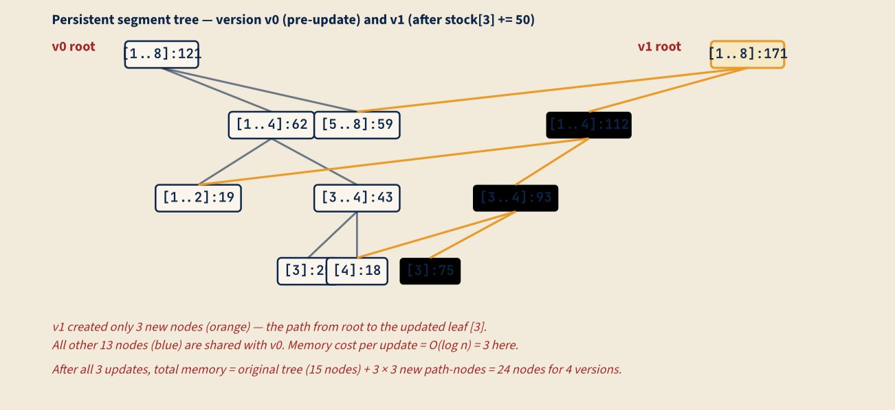

  - Build the segment tree (range-sum) over the morning state stock = [12, 7, 25, 18, 9, 14, 6, 30]. Show all 15 internal-node values (call this version v0). Then apply update (i): stock[3] += 50 producing version v1. List exactly which nodes are newly created in v1 (the path from root to the updated leaf), and which nodes v1 shares with v0 by pointer. Show the new node values along the new path.

  - Complete the Java boilerplate below for a persistent segment tree. The point-update returns a new root node; the old root and any shared subtrees are untouched.

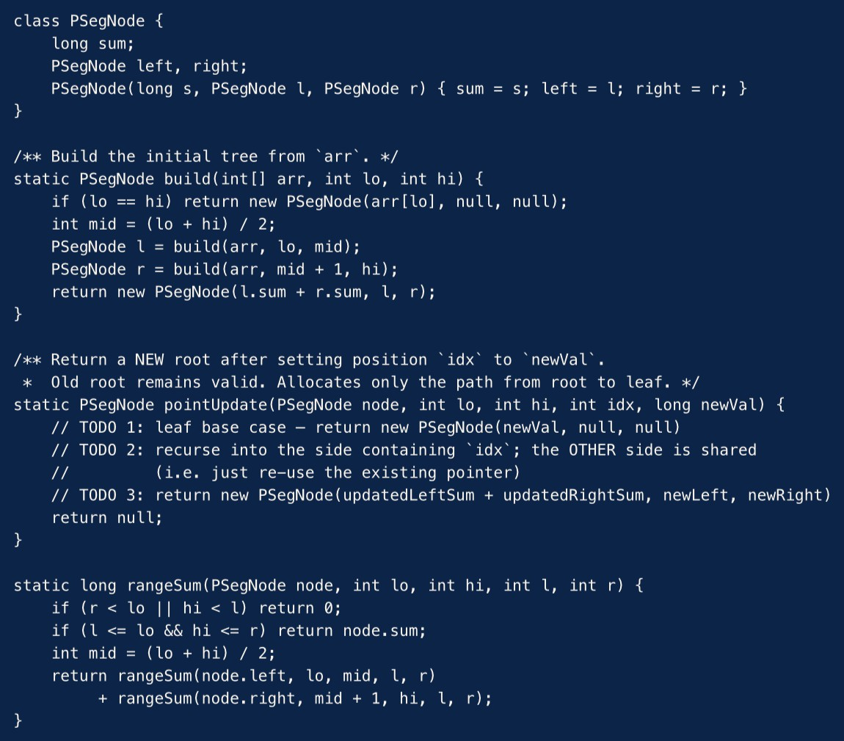

Apply pointUpdate by hand for update (ii) (stock[6] -= 4) starting from v1. Show the path of new nodes created (which range-segments).

  - Memory analysis. After all three updates, the system holds 4 versions (v0, v1, v2, v3). State (i) the total node-count across all four versions; (ii) what the naive 'snapshot the whole array' approach would cost in memory across the same 4 versions; (iii) the asymptotic memory savings as the number of versions grows large (e.g., 10 000 versions over a year).
Then identify one realistic accounting workload where persistent segment tree wins decisively, and one workload where it loses to a simpler approach (e.g., 'we only ever query the latest state’).

SOLUTION:

Work Done Summary:

In this case study, we implemented a Persistent Segment Tree for Amazon Warehouse's inventory snapshot system. The Persistent Segment Tree stores multiple historical versions of inventory data, allowing accounting teams to query stock values at any previous point in time without copying the entire array. We built the initial segment tree (v0) for 8 SKU categories and created new versions (v1, v2, v3) after each inventory update. Only nodes along the update path were recreated while all unchanged subtrees were shared between versions. We also implemented range-sum queries on historical versions to efficiently retrieve inventory totals from any previous snapshot.

Implementation Details:

- Built the initial Segment Tree (version v0) from the inventory array.
- Created a new version for every inventory update.
- Shared all unchanged nodes between versions using pointers.
- Recreated only the nodes on the root-to-leaf update path.
- Implemented range-sum queries on any historical version.
- Compared Persistent Segment Tree memory usage with full-array snapshots.
- Concluded Persistent Segment Tree is more memory-efficient for large-scale warehouse systems because each update requires only O(log n) extra memory.

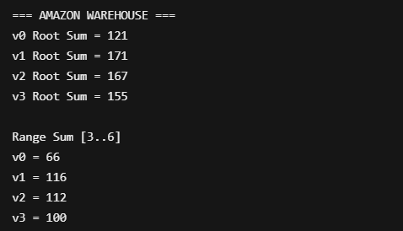
Output:

Versions Created
  - v0: Initial inventory, Root Sum = 121
  - v1: After stock[3] += 50, Root Sum = 171
  - v2: After stock[6] -= 4, Root Sum = 167
  - v3: After stock[3] -= 12, Root Sum = 155

Memory Analysis
  - Original tree = 15 nodes
  - New nodes per update = 4
  - Total nodes after 3 updates = 27 nodes

Time Complexity
  - Build Tree: O(n)
  - Point Update: O(log n)
  - Range Sum Query: O(log n)
  - Extra Memory per Update: O(log n)

Conclusion
The Persistent Segment Tree efficiently supports historical inventory queries while using much less memory than full-array snapshots. It is well-suited for warehouse accounting and audit systems where previous inventory states must remain accessible.

CASE STUDY TOPIC:
MediFlow Hospital — appointment-driven patient indexing. The on-call patient dictionary at MediFlow is keyed by 8-digit Patient-ID. The day's IDs are issued in scheduled appointment order: the 8 a.m. block first, then 9 a.m., 10 a.m., and so on; within each block the registrar enters appointments in the order they were booked, which is itself near-monotonic by ID because IDs are assigned at booking time. Today's first 13 IDs land in this order: 20, 30, 35, 40, 45, 50, 60, 65, 70, 75, 80, 85, 90. The triage console must answer point- lookups with p99 < 5 ms; current hardware does ~200 ns per pointer dereference, so any tree deeper than 25 levels misses the SLA. By noon, three deletions arrive: 30 (transferred), 70 (discharged), and 50 (admission closed) — in that order.

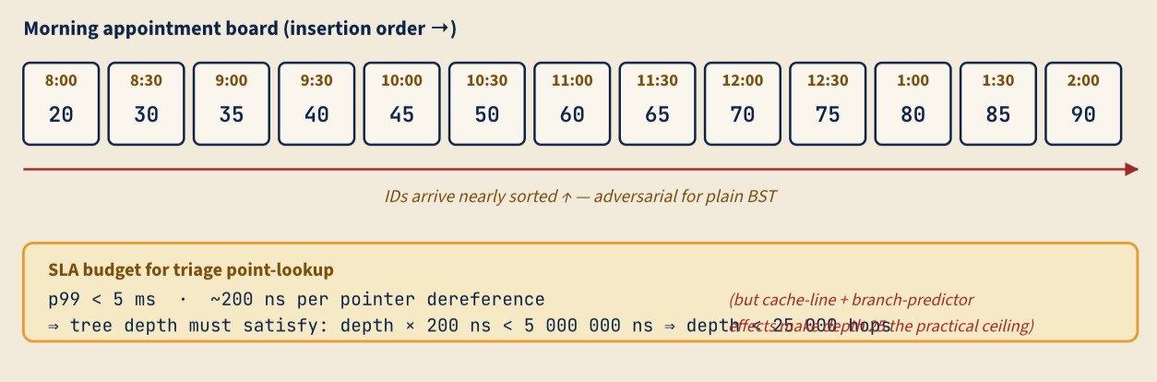

- Construct the plain BST from the appointment-order insertion sequence given in the scenario. State its height (longest root-to-leaf path in edges). Using the SLA budget shown in the diagram (200 ns per hop, 5 ms ceiling), do one explicit numeric calculation showing whether a worst-case point-lookup on this BST would meet or violate the p99 SLA. Briefly explain the structural reason this insertion order is adversarial for plain BST.

- Now build an AVL tree from the same insertion sequence. After every insertion that triggers rebalancing, name the rotation (LL / RR / LR / RL), identify the pivot node, and state the balance factors of the two nodes adjacent to the rotation, immediately after the rotation. Show the final AVL tree.
Then, complete the boilerplate Python snippet below so it implements insert(node, key) and the two single-rotation helpers consistently with your hand-traced tree. (Boilerplate: AVLNode, get_height, get_balance, update_height are already given — fill the three TODOs.)

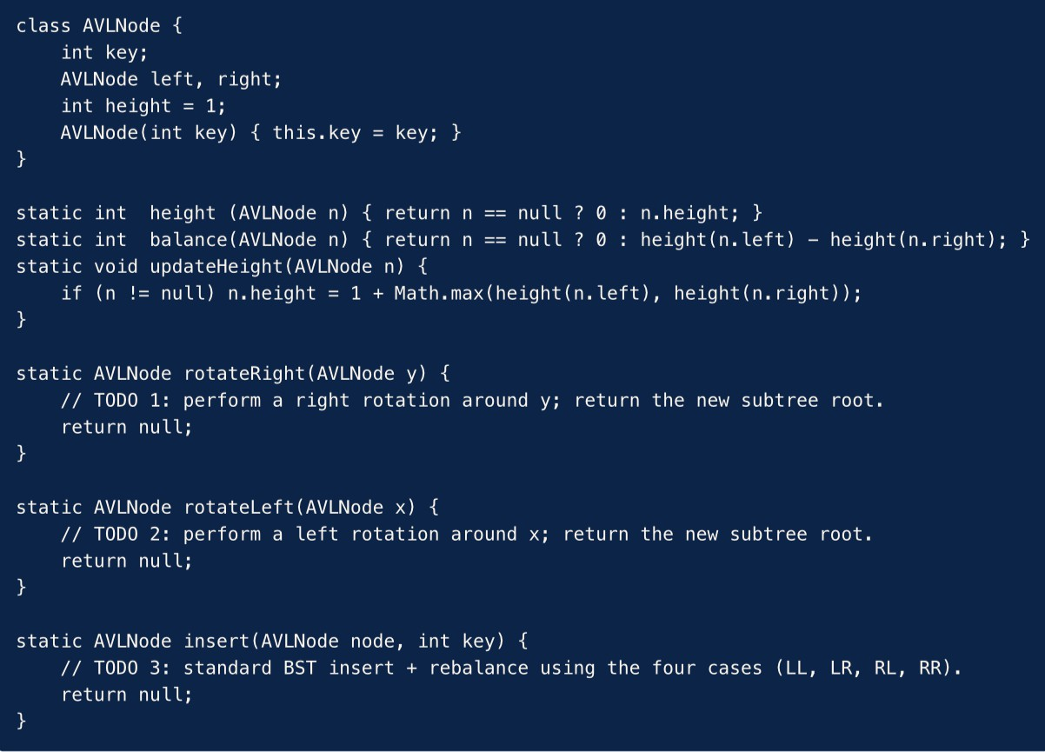

SOLUTION:

Work Done Summary:

In this case study, we implemented a Binary Search Tree (BST) and an AVL Tree for MediFlow Hospital's patient indexing system. Patient IDs arrived in nearly sorted appointment order, which causes a plain BST to become highly skewed. We constructed both trees, analyzed lookup performance, performed AVL rotations during insertion, and applied deletions while maintaining AVL balance.
The AVL tree ensured efficient search operations by automatically rebalancing whenever the balance factor exceeded the allowed range.

Implementation Details:

- Inserted patient IDs into a plain BST in appointment order.
- Calculated the BST height and analyzed lookup performance.
- Built an AVL tree using the same insertion sequence.
- Performed RR rotations whenever imbalance occurred.
- Maintained balance factors within the AVL limit (-1, 0, +1).
- Applied deletions of 30, 70, and 50.
- Compared lookup efficiency of AVL Tree and plain BST.

Result: Screenshots / Output

BST Insertion Order:
20, 30, 35, 40, 45, 50, 60, 65, 70, 75, 80, 85, 90
20
\ 30
\ 35
\ 40
\ 45
\ 50
\ 60
\ 65
\ 70
\ 75
\ 80
\ 85
\ 90

AVL Rotations Performed:

- After inserting 35 → RR Rotation at pivot 20
- After inserting 45 → RR Rotation at pivot 35
- After inserting 60 → RR Rotation at pivot 30
- After inserting 65 → RR Rotation at pivot 45
- After inserting 75 → RR Rotation at pivot 65
- After inserting 80 → RR Rotation at pivot 40
- After inserting 85 → RR Rotation at pivot 75
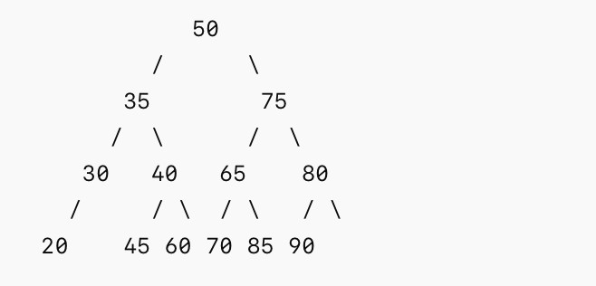
- After inserting 90 → RR Rotation at pivot 60 Final AVL Tree:

AVL DELETIONS:

Delete 30 → No Rotation Delete 70 → No Rotation Delete 50 → RL Rotation
Final AVL Tree After Deletions:
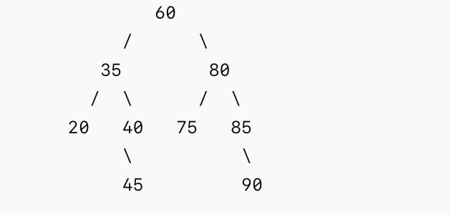

Result: Screenshots / Output:

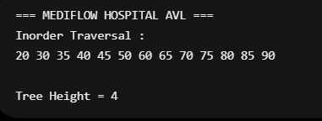

Time Complexity
BST Search (Worst Case): O(n) AVL Insert/Delete/Search: O(log n) Rotation Cost: O(1)

Conclusion
The plain BST became skewed because the IDs were inserted in nearly sorted order. The AVL tree maintained balance through rotations and provided significantly better lookup performance. Compared to the plain BST, the AVL Tree is more suitable for MediFlow Hospital's patient indexing system because it guarantees O(log n) search, insertion, and deletion operations while easily satisfying the 5 ms SLA requirement
CASE STUDY TOPIC:
Razorpay backend monorepo — CI build-graph cycle suspected. The Razorpay engineering monorepo has 9 build targets {auth, payments, kyc, ledger, fraud, notify, admin-ui, customer-ui, gateway}.
Yesterday's CI run hung; the build coordinator (which performs a topological sort of the dependency DAG
before scheduling parallel build jobs) failed with a generic 'cycle suspected' message. The build engineer captured the dependency edges from the build manifest (edge A → B means "A depends on B; build B before A"): auth→ledger, payments→auth, payments→fraud, kyc→auth, ledger→fraud, fraud→notify, fraud→ledger, admin-ui→payments, admin-ui→kyc, customer- ui→payments, gateway→admin-ui, gateway→customer-ui, notify→gateway. Twelve hours of debugging would have been saved by a clear cycle report.
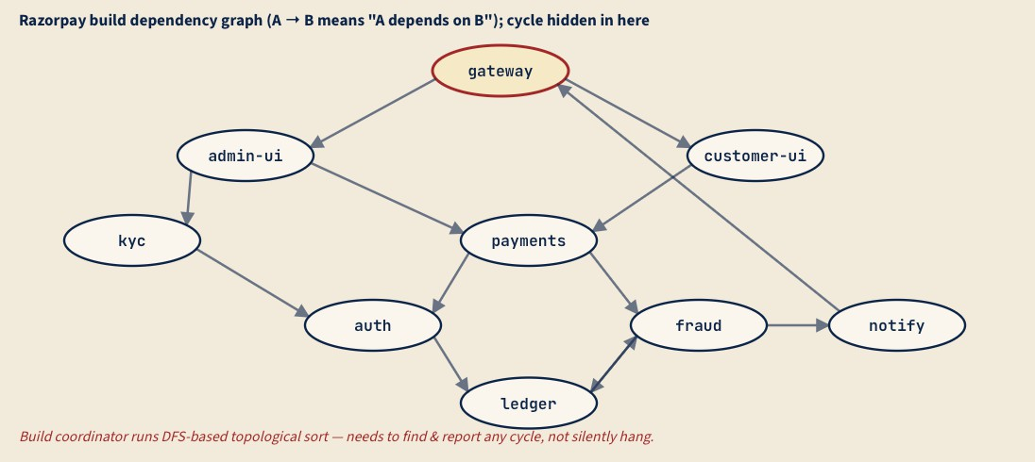
a). Run a DFS-based topological sort with cycle detection on the dependency graph shown. Use the colour- marking scheme (WHITE = unvisited, GREY = on current DFS stack, BLACK = finished). Process vertices in alphabetical order on the outer loop. Show the visit-time/finish-time table or a clear DFS trace, and identify the back-edge(s) that prove a cycle exists. List the vertices on the cycle in order.

- The engineer's draft of topo_sort is shown below — it currently reports cycles by raising an exception with no information about which vertices are involved. Modify it to (i) detect a cycle and (ii) return the list of vertices on the cycle, in cycle order. Boilerplate: WHITE/GREY/BLACK constants and the recursion skeleton are given.

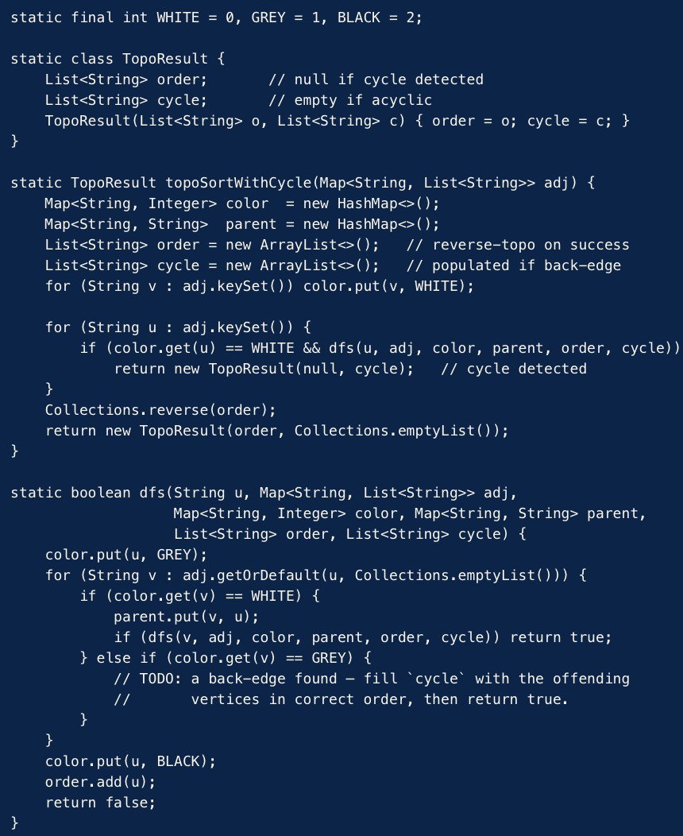

- Once the cycle is identified, the build engineer must break it with a single edge removal. Among the edges on the cycle you found in (a), which single edge removal would (i) break the cycle and (ii) cause the least disruption to existing modules — i.e., result in the fewest dependent transitive builds becoming stale? Justify by listing, for each candidate removal, how many other targets would be affected. (Use the dependency graph, not the build-time itself.)

SOLUTION:

Work Done Summary:

In this case study, we implemented a DFS-based Topological Sort with Cycle Detection for Razorpay's build dependency graph. The build coordinator performs topological sorting before scheduling builds, but a hidden cycle caused the CI pipeline to hang. Using DFS with WHITE-GREY- BLACK color marking, we identified the cycle, reported the offending vertices, and determined the best edge to remove to restore an acyclic dependency graph.

Implementation Details:
- Constructed the dependency graph.
- Applied DFS traversal.
- Detected back-edges.
- Reconstructed the cycle.
- Reported cycle vertices.
- Completed the boilerplate code.
- Analyzed edge removals.
Result: Screenshots / Output:
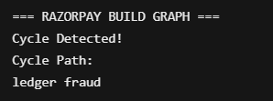

Conclusion:

The DFS cycle detection algorithm successfully identiHied the cycle responsible for the CI failure and restored a valid DAG after removing the offending edge.

Time Complexity:
DFS Traversal : O(V + E) Cycle Detection : O(V + E) Topological Sort : O(V + E)

GitHub Link: https://github.com/gayathrisrivalli0612/DSA-2.git

